**Practical:3**

**Virtualization and Cloud Computing (CSE 427) Using the VMWare Hands on Laboratory for Creation of**

**HyperVisor Type 1.**

Name : Kumar Aditya Regno : 12109218

Rollno : K21FHA13

1. **Creating a new Virtual Machine using the Actions tab.**

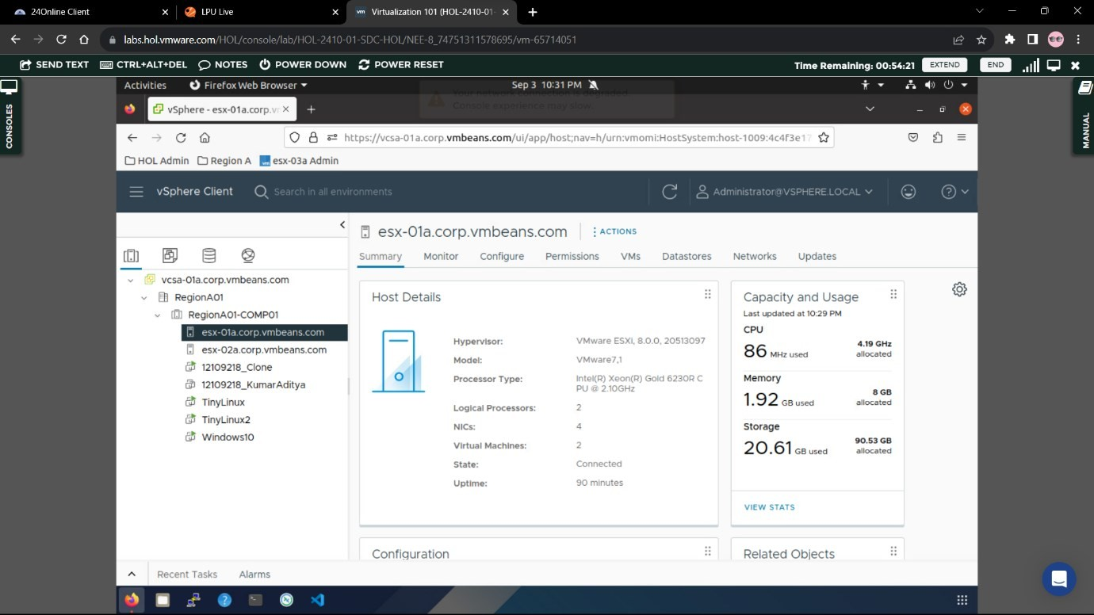

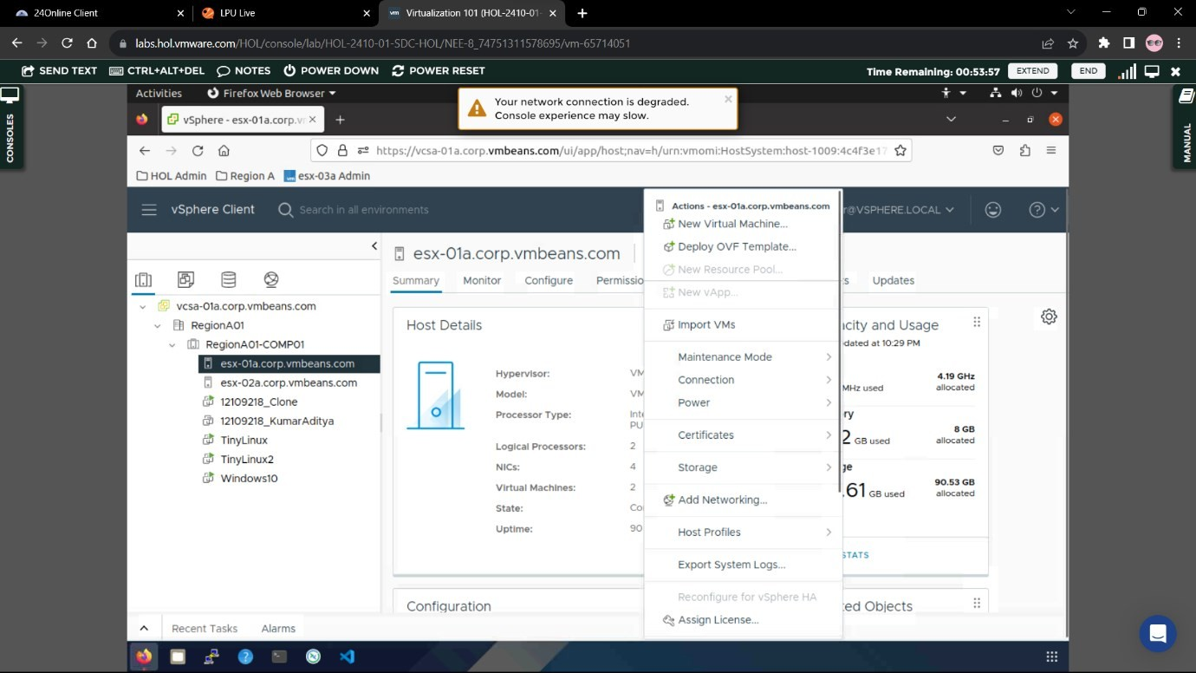

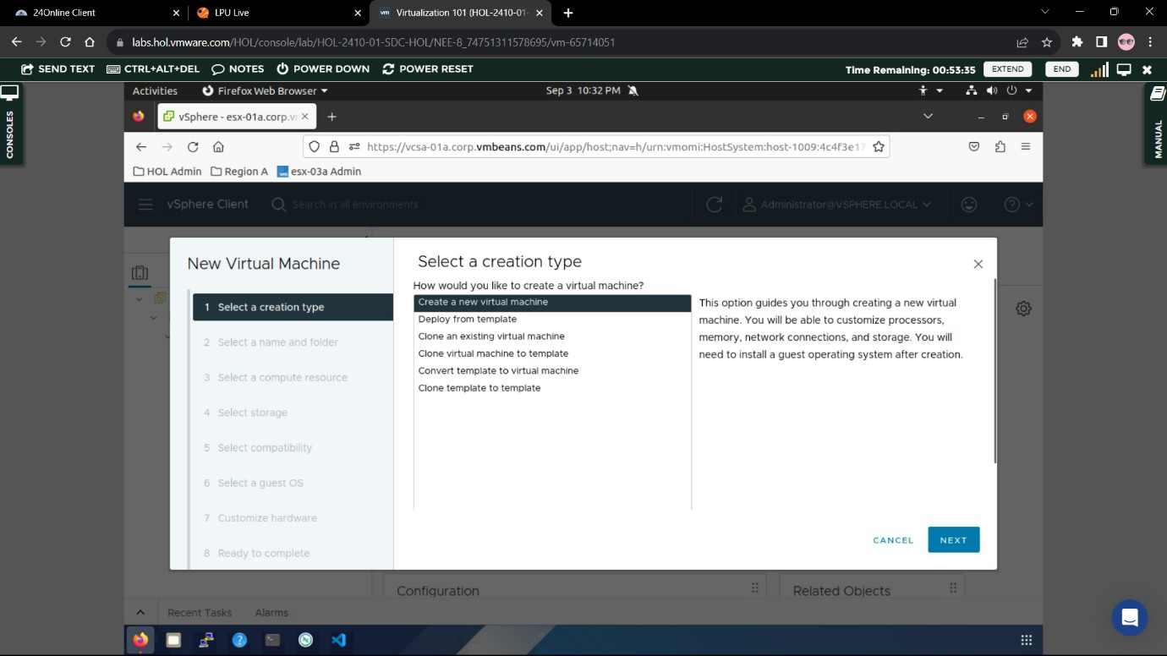

1. **Provide a name for your virtual machine .**

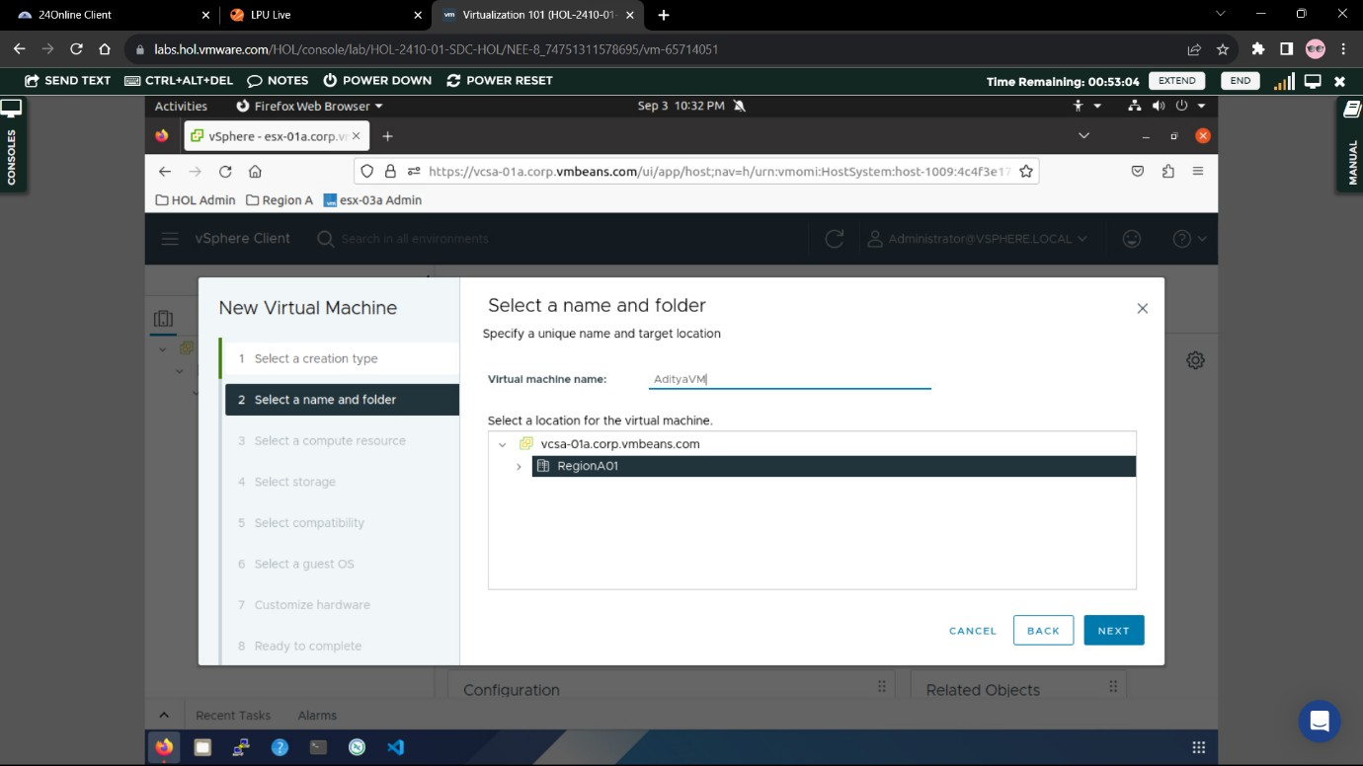

1. **Select the resources .**

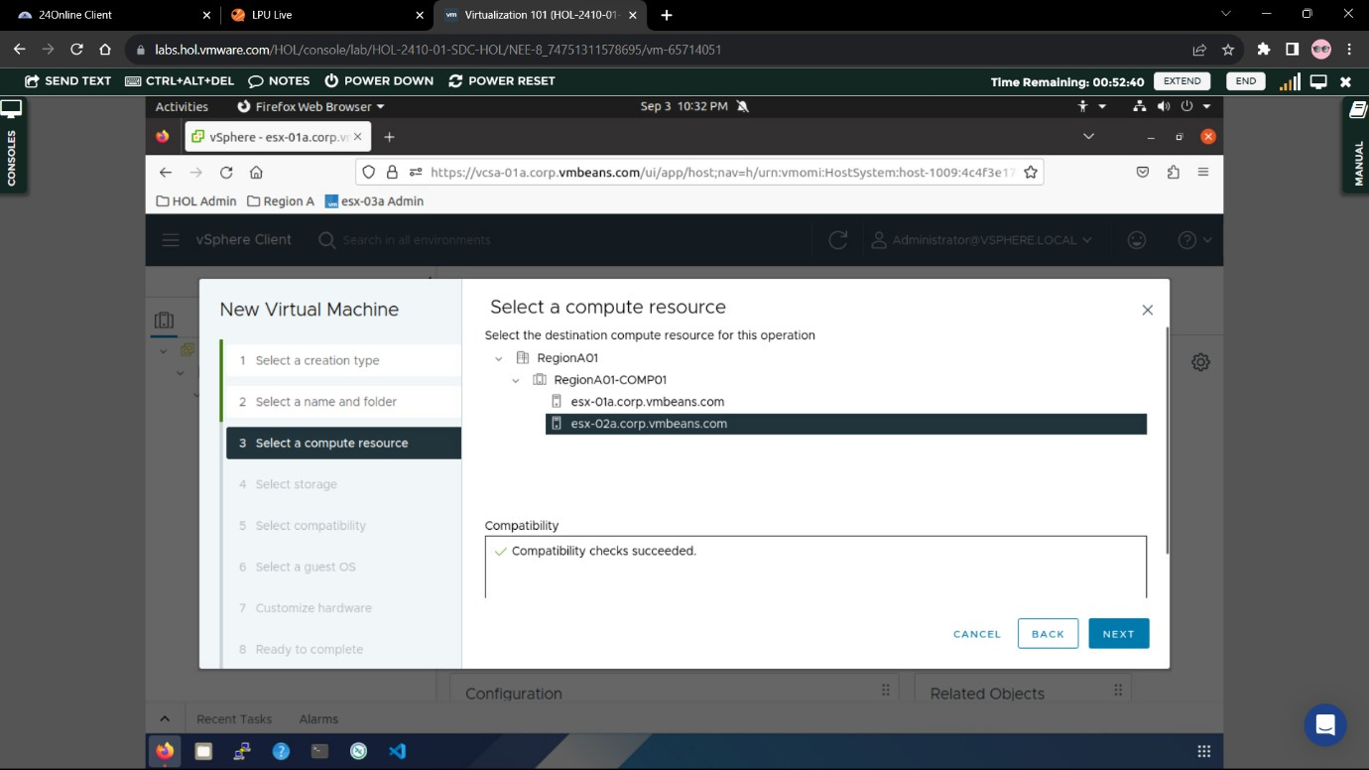

1. **Select NFS01 as storage for the virtual machine .**

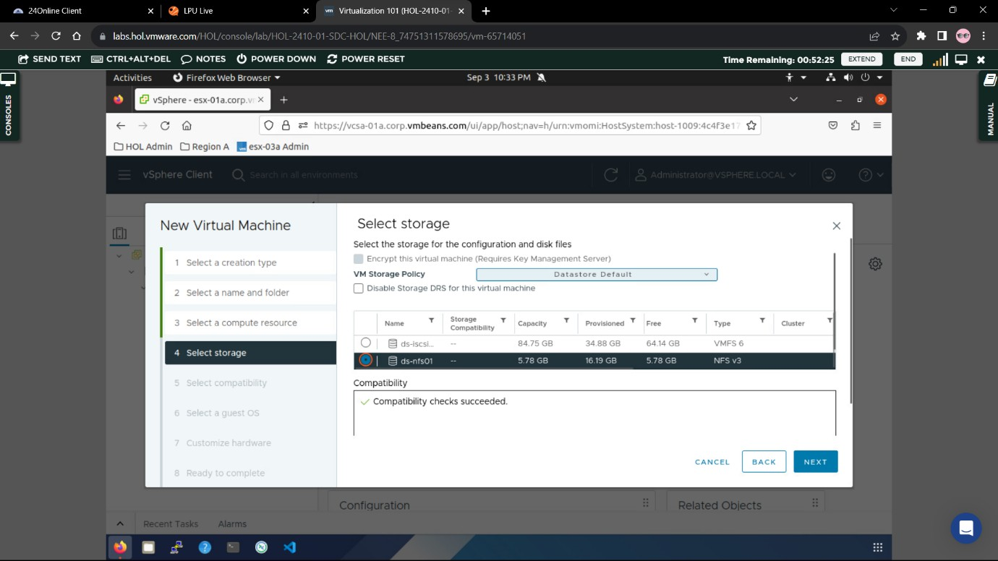

1. **For Compatibility choose the option from the drop down menu called (ESXi**

6.2 U2 and Later) .

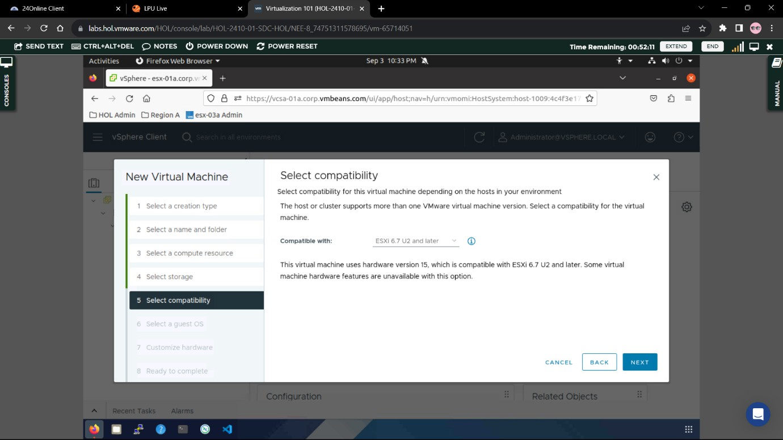

1. **Select Linux as Guest OS Family and VMWare Photon as the version .**

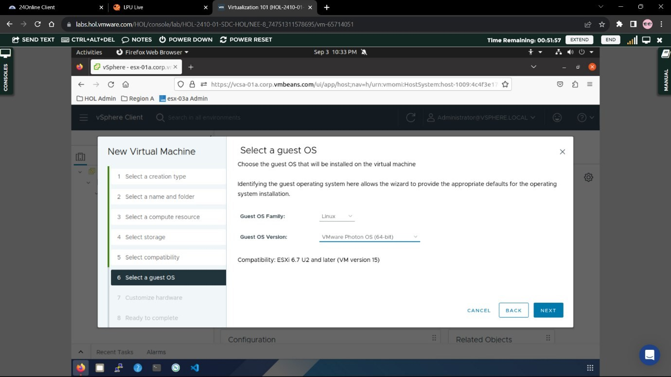

1. **Customize hardware according to your suitability .**

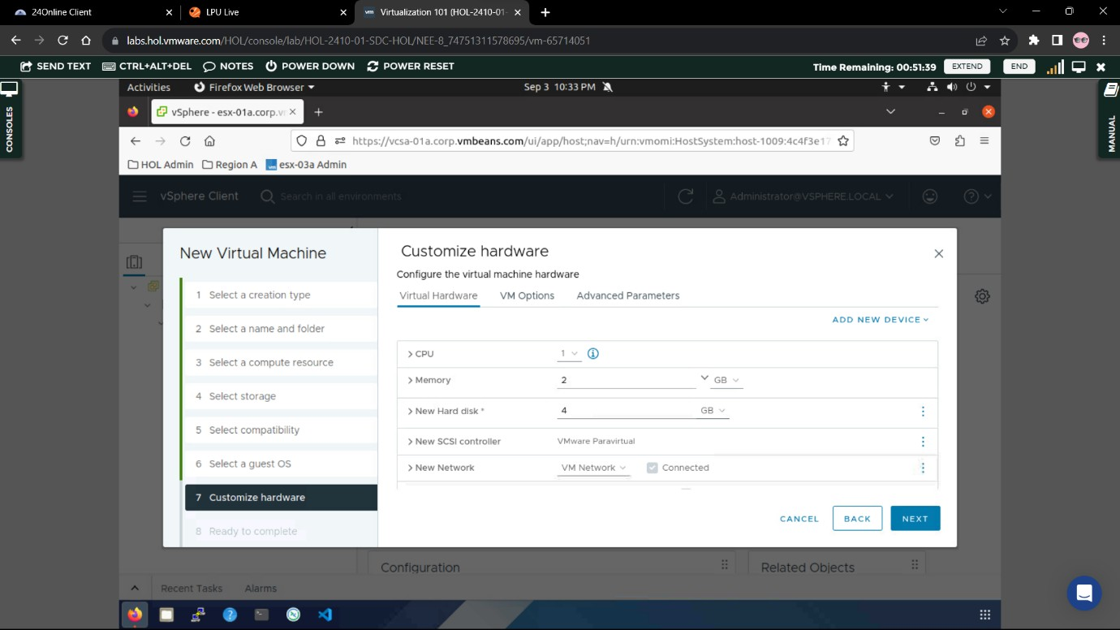

1. **Finalize to create the virtual machine .**

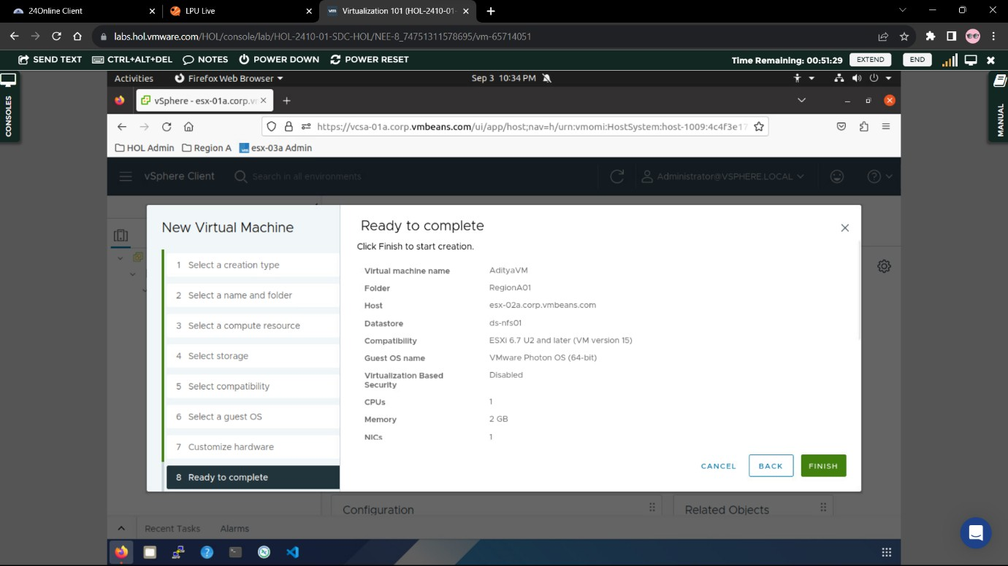

1. **Now we need to create a clone for the existing VMWare virtual machine .**

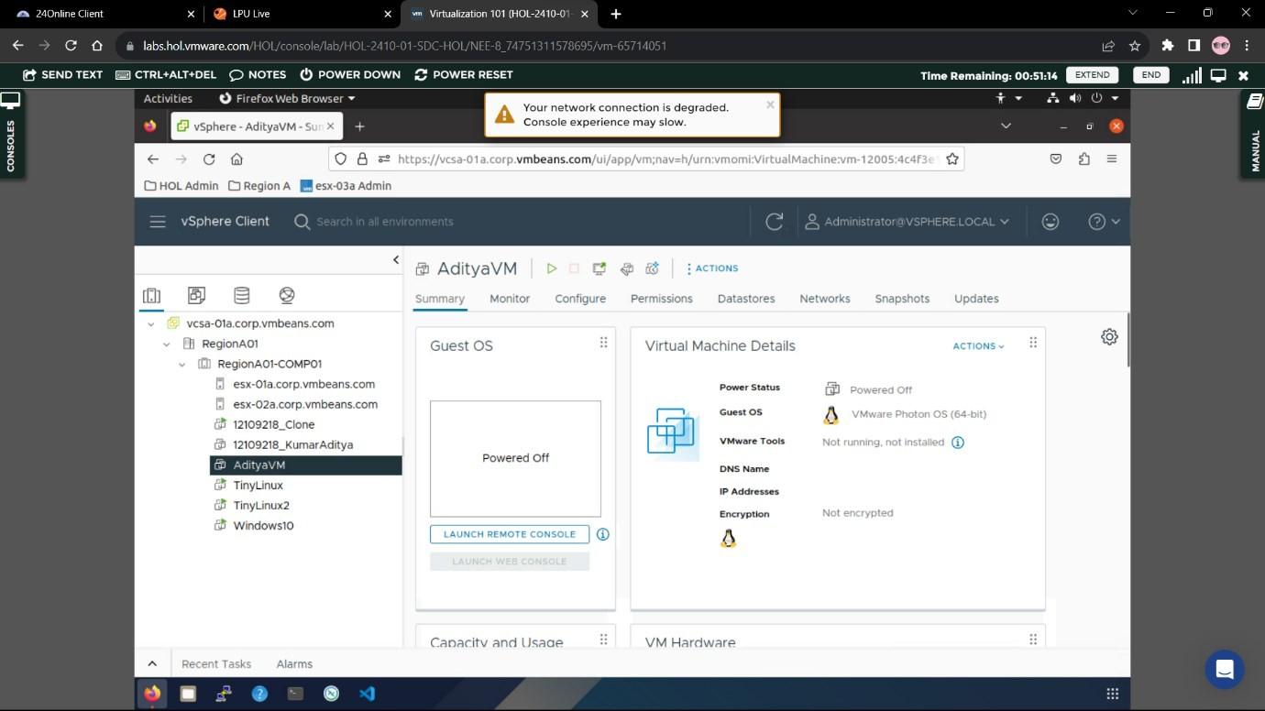

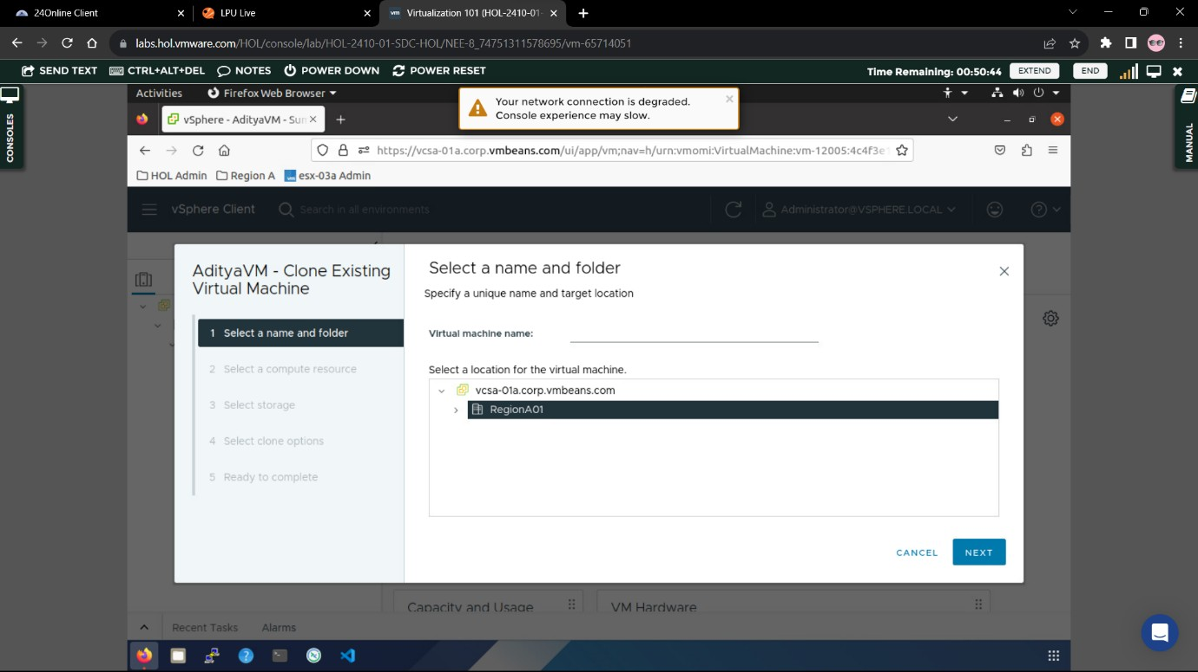

1. **Select the resources for the clone machine .**

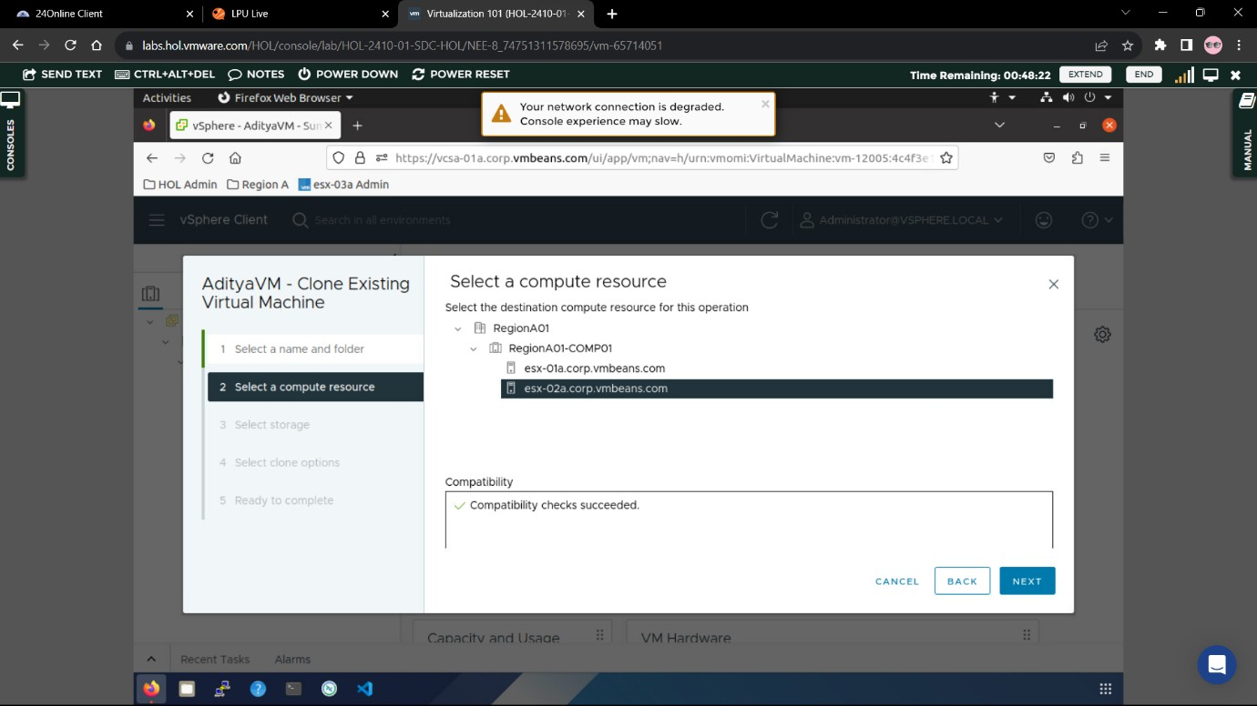

1. **Select storage for the Virtual Machine Clone .**

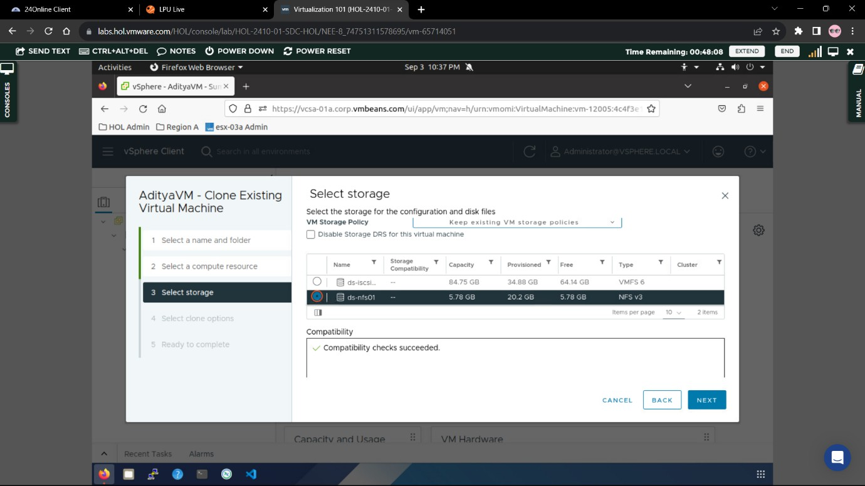

1. **Finalize the settings to complete the clone installation .**

